Teacher Notes for “Introduction to Cells”

This minds-on analysis and discussion activity begins with an anchoring phenomenon – a video of a eukaryotic cell chasing and eating a bacterium. This leads to analyses of how cells carry out the activities of life and the similarities and differences between eukaryotic and prokaryotic cells. Additional topics include the functions of the organelles in eukaryotic cells and the differences between animal and plant cells.

Table of Contents
Learning Goals – pages 1-2
Instructional Suggestions and Background Biology – pages 2-10
Recommended Follow-Up Activity and Sources of Figures in Student Handout – pages 10-11
Appendices with Possible Additions to Student Handout – pages 12-16

Learning Goals
In accord with the Next Generation Science Standards:
- This activity helps students to prepare for the Performance Expectations:
- MS-LS1-2. "Develop and use a model to describe the function of a cell as a whole and ways parts of cells contribute to the function."
- Students learn the following Disciplinary Core Ideas (LS1.A):
- "All living things are made up of cells, which is the smallest unit that can be said to be alive. An organism may consist of one single cell (unicellular) or many different numbers and types of cells (multicellular)."
- "Within cells, special structures are responsible for particular functions…"
- Students engage in recommended Scientific Practices, including "Constructing Explanations. Apply scientific ideas, principles, and/or evidence to provide an explanation of phenomena in natural… systems."
- This activity helps students to learn the Crosscutting Concept: Structure and function. "Complex and microscopic structures and systems can be visualized, modeled, and used to describe how their function depends on the shapes, composition, and relationships among its parts; therefore, complex natural and designed structures/systems can be analyzed to determine how they function."

Additional Content Learning Goals include:
- All cells have DNA, ribosomes, a cell membrane, and cytoplasm (which includes cytosol and the structures embedded in the cytosol).
- Eukaryotic cells have a true nucleus with a membrane around the DNA and additional membrane-enclosed organelles. Prokaryotic cells do not have membrane-enclosed organelles.
- Prokaryotes include bacteria and archaea. Bacteria and archaea have fundamental differences at the molecular level.
- Some prokaryotes have chemical capabilities that are not found in eukaryotes. For example, some prokaryotes can use N₂ to make NH₄⁺ which can be used to make amino acids.
- Membrane-enclosed organelles in eukaryotes include:
  - the nucleus (which contains DNA with the instructions for making proteins),
  - the rough endoplasmic reticulum and Golgi apparatus (which, together with the ribosomes on the rough endoplasmic reticulum, produce and process the proteins that are secreted from the cell),
  - mitochondria (which make ATP which provides the energy for protein synthesis and many other cellular processes).
- Different organelles work together to accomplish the activities of life.

Instructional Suggestions and Background Biology
You can maximize student participation and learning by having your students work in pairs or small groups to complete groups of related questions, and then having a class discussion of each group of related questions. In each discussion, you can probe student thinking and help them develop a sound understanding of the concepts and information covered, before moving on to the next group of related questions.

If your students are learning online, I recommend that they use the Google Doc version of the Student Handout available at https://serendipstudio.org/exchange/bioactivities/CellIntro. To answer questions 4, 9-10, and 12, students can either print the relevant pages, draw on them and send pictures to you, or they will need to know how to modify a drawing online. To answer online, they can double-click on the relevant drawing in the Google Doc to open a drawing window. Then, they can use the editing tools to answer the questions.

You may want to revise the GoogleDoc or Word document to prepare a version of the Student Handout that will be more suitable for your students. If you use the Word document, please check the format by viewing the PDF.

A key is available upon request to Ingrid Waldron (iwaldron@upenn.edu). The following paragraphs provide additional instructional suggestions and background information – some for inclusion in your class discussions and some to provide you with relevant background that may be useful for your understanding and/or for responding to student questions.

The first paragraph of the Student Handout introduces the important point that cells are the smallest unit that is alive. Cell Theory includes two additional points.
- All organisms are made up of one or more tiny cells.
- All cells come from already existing cells. (https://bio.libretexts.org/Bookshelves/Human_Biology/Book%3A_Human_Biology_(Wakim_and_Grewal)/05%3A_Cells/5.02%3A_Discovery_of_Cells_and_Cell_Theory)

If your students have not already learned the characteristics or activities of life, you may want to precede this “Introduction to Cells” activity with the analysis and discussion activity, “Characteristics of Life” (https://serendipstudio.org/exchange/bioactivities/lifecharacteristics). Your students should understand that cells are alive, but individual molecules are not. Thus, life is an emergent property at the level of the cell due to the specific organization of molecules within the cell. You may want to ask your students the following question in order to reinforce student understanding that life depends on the specific organization of molecules within the cell.

1. If you ground up a cell and put all the molecules from the cell in a mini-test tube, would this mixture of molecules be alive? Explain why or why not.

Question 1 of the Student Handout introduces an anchoring phenomenon – the 1-minute video, “Neutrophil Chasing a Bacterium” (https://www.youtube.com/watch?v=I_xh-bkiv_c). In this video, a eukaryotic phagocytic cell uses chemical information to pursue and then eat a bacterium. Students will see the dynamic changes in shape as the phagocytic cell moves, as well as the substantial difference in size between eukaryotic and prokaryotic cells. This video introduces the theme that, even though typical cell diagrams are static, real cells are dynamic and carry out the activities of life (e.g., responding to the environment and getting and using energy).

Students may wonder about how the phagocytic cell moves. The figure at right shows one mechanism. Changes in the proteins of the cytoskeleton play a major role in the movement of phagocytic white blood cells (as briefly mentioned in the middle of page 1 of the Student Handout). Specifically, actin polymerization moves the leading edge forward, and at the rear interactions between actin and the motor protein myosin move the nucleus forward (https://www.nature.com/articles/nature06887). | (https://www.researchgate.net/publication/261515905_Podosomes_in_space)
nucleus
The Student Handout description of the cell parts found in all cells does not mention some exceptions. For example, during the final stages of development of mammalian red blood cell the nucleus and mitochondria are ejected, so mature red blood cells do not have DNA. The membrane that surrounds a cell is often called the plasma membrane, in order to distinguish it from the membranes inside the cell (especially in eukaryotic cells). Students can learn more about the cell membrane in the hands-on activity, “Cell Membrane Structure and Function” (https://serendipstudio.org/sci_edu/waldron/#diffusion). In your class discussion of student answers to question 2, you will want to include the contribution of the cell membrane to homeostasis and the contribution of DNA and ribosomes to protein synthesis which contributes to cell growth. You may also want to mention that molecular changes in the cytoskeleton caused movement and thus helped the animal cell respond to its environment.

Question 3 is intended to stimulate students to remember what they have learned previously about bacteria and animal cells, so they can link the information in this activity to previous learning. A review of student answers will help you to identify any misunderstandings; these can be corrected as you discuss the subsequent pages of the Student Handout.

The defining difference between prokaryotic and eukaryotic cells is that eukaryotic cells have a membrane surrounding their DNA and prokaryotic cells do not. Eukaryotic means that the cell has a true nucleus (i.e., DNA surrounded by a nuclear membrane). (The word eukaryote comes from the Greek “eu”, meaning true, and karyon, meaning nut or kernel. The word prokaryotic comes from the Greek “pro”, meaning before, and karyon, meaning nut or kernel.)

The figure on page 2 of the Student Handout defines an organelle as “a part of a cell that has a specialized function”. This definition includes ribosomes. Some sources restrict the definition of an organelle to membrane-enclosed organelles, which excludes ribosomes.

This figure shows more information about a “typical” prokaryotic cell. The cell wall provides structure and protection. The capsule with its pili enables the cell to attach to surfaces in its environment. The DNA is in a circular chromosome (as opposed to the linear chromosomes in eukaryotic cells). Not all prokaryotes have flagella.  Prokaryotes differ in size, shape and ability to move. For example, some prokaryotic cells have a diameter as small as 0.2 µm or as large as 100 µm. | 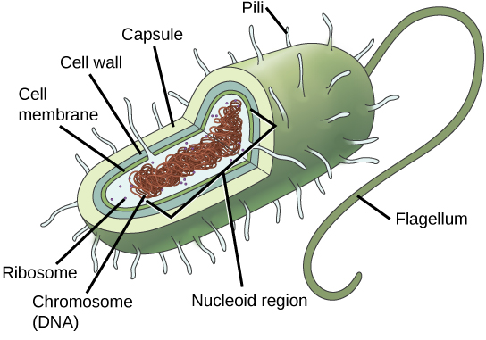  (https://courses.lumenlearning.com/suny-wmopen-biology1/chapter/prokaryotes-and-eukaryotes/)

With regard to question 4a, you may want to point out that, if a eukaryotic cell has a diameter which is 10 times larger than a prokaryotic cell, then the volume of the eukaryotic cell is 10³ = 1000 times larger. Similarly, if a eukaryotic cell has a diameter which is 100 times larger than a prokaryotic cell, then the volume of the eukaryotic cell is 100³ = 1 million times larger.

Although prokaryotes are generally described as unicellular, it has been estimated that 40-80% of all prokaryotes live in biofilms (see figure below). In a biofilm:
- A secreted extracellular substance provides protection.
- Some of the cells have differing metabolisms and functions, and they cooperate to support the survival and propagation of the biofilm.

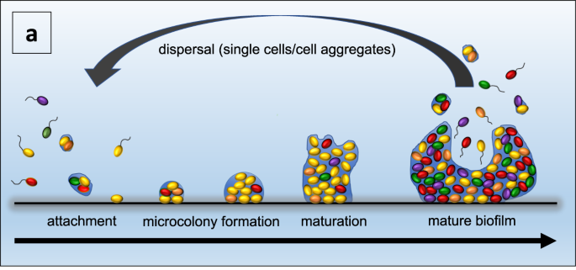
Single, motile prokaryotic cells or cell aggregates attach to a substratum. Then, cells divide and some of the cells secrete extracellular matrix. When a biofilm is mature, it releases single motile cells or cell aggregates which disperse. (https://www.nature.com/articles/s41522-021-00251-2)

Prokaryotes are diverse, numerous, and nearly ubiquitous on earth. Scientists believe that there are millions of different species of prokaryotes alive today, although only about 5000 species have been formally named and described thus far. A teaspoon of good quality soil contains billions of prokaryotes, and a milliliter of ocean water typically contains roughly 10,000 prokaryotes. Scientists estimate that the total number of individual bacteria and archaea alive today is over 5x 10³⁰. They estimate that, despite their tiny size, there are so many prokaryotes that they weigh roughly as much as all the eukaryotes on earth. Research has shown that various prokaryotes can survive in a broad range of environments, including in and on our bodies, in the soil, in the oceans, and in water-filled cracks in the earth’s crust 2.5 km below the ocean floor (at temperatures that range from 0°C to ~120°C and at high pressures; https://www.quantamagazine.org/inside-deep-undersea-rocks-life-thrives-without-the-sun-20200513/). The remarkable metabolic diversity of prokaryotes includes the ability to obtain the energy for the activities of life from sunlight, from organic molecules like sugars, or from inorganic molecules like ammonia or methane.

Prokaryotes are sometimes thought of as “germs” and are assumed to be harmful, but humans derive multiple benefits from prokaryotes. Two examples are described on the bottom of page 2 and the top of 3 of the Student Handout. To answer question 5, students should notice that animals obtain amino acids from plants (or animals that eat plants), and plants depend on prokaryotes to convert the abundant N₂ in air to NH₄⁺ which plants can use to make amino acids. The figure below shows the important roles of bacteria in the nitrogen cycle.

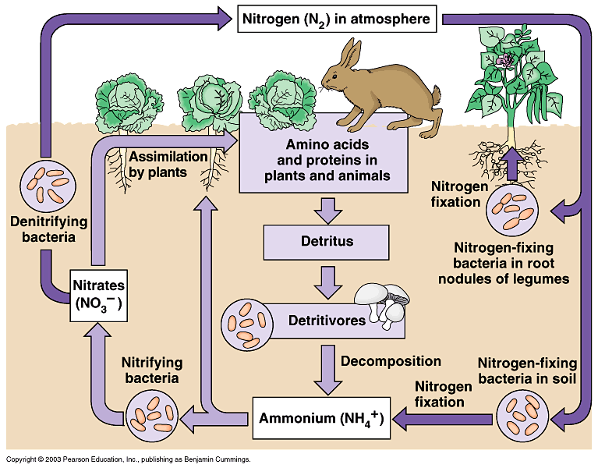
(https://i.pinimg.com/originals/21/e3/66/21e36612329d77271bdcfae88d8232f7.gif)

The number of prokaryotic cells that are in and on the human body is sometimes said to be ten times as great as the number of human cells in a body, but recent improved estimates indicate that the number of prokaryotic and human cells is roughly equal. For example, one study estimated that a typical man has roughly 30 trillion human cells and 38 trillion prokaryotic cells (https://journals.plos.org/plosbiology/article?id=10.1371/journal.pbio.1002533). A typical woman’s body was estimated to have roughly 21 trillion human cells; the sex difference is due primarily to women’s lower number of red blood cells. (Red blood cells are estimated to be 84% of human cells.) Another study produced somewhat higher estimates – 36 trillion human cells in a typical man and 28 trillion human cells in a typical woman (https://www.pnas.org/doi/10.1073/pnas.2303077120). Many of the prokaryotes living in or on humans are in the contents of the colon. The relationship between humans and our microbiome is an example of a mutually beneficial symbiosis. (A symbiosis occurs when two different species live together in direct and intimate contact.) You may want to contrast this mutualism with parasitism in the case of disease-causing bacteria.

You may need to emphasize for your students the logarithmic scale in the figure on page 3 of the Student Handout. That figure provides the basis for estimating that a woman is about 10⁴-10⁵ times as tall as the diameter of an animal cell. We can start from this estimate to calculate how a human body can contain 30 trillion = 3 x 10¹³ human cells. To estimate volume, diameter should be cubed, so there is room for roughly (10⁴)³– (10⁵)³ = 10¹² – 10¹⁵ animal cells in a human body. These estimates bracket the estimated number of human cells in a human body = 3 x 10¹³.

The animation recommended in question 7 (https://learn.genetics.utah.edu/content/cells/scale/) should help your students develop an intuitive understanding of how tiny cells are. If you want your students to learn that surface-area-to-volume ratio is a major reason why cells are so tiny, you can use the questions in Appendix 1.

As explained on page 3 of the Student Handout and in the recommended 5-minute video, “Prokaryotic vs. Eukaryotic Cells” (https://www.youtube.com/watch?v=Pxujitlv8wc), there are two fundamentally different types of prokaryotes – bacteria and archaea. These differences are molecular and difficult for beginning biology students to understand. These molecular differences explain why many antibiotics that can kill bacteria or slow the growth of bacterial populations have little or no effect on archaea (https://www.clinicalmicrobiologyandinfection.com/article/S1198-743X(14)61060-0/fulltext). In some ways, archaea are more similar to eukaryotic cells than to bacteria (https://www.easybiologyclass.com/compare-archaebacteria-bacteria-and-eukaryotes-similarities-and-differences-table/; https://microbenotes.com/archaea-vs-bacteria/).

Good sources for more information on prokaryotes are:
- https://bio.libretexts.org/Bookshelves/Introductory_and_General_Biology/Book%3A_Concepts_in_Biology_(OpenStax)/13%3A_Diversity_of_Microbes%2C_Fungi%2C_and_Protists/13.1%3A_Prokaryotic_Diversity
- https://www.coursehero.com/sg/introduction-to-biology/prokaryotes-bacteria-and-archaea/ (including a 6.5-minute video)

Before question 9 (or before you begin page 4 of the Student Handout), you may want to show the 7-minute video, “Biology: Cell Structure” (https://www.youtube.com/watch?v=URUJD5NEXC8). One inaccuracy in this video is that the narrator states that proteins are folded in the Golgi apparatus, whereas actually proteins are folded in the rough endoplasmic reticulum.

Question 9 reinforces student understanding that different parts of a eukaryotic cell work together to accomplish specific functions. For example, the following organelles cooperate to synthesize and secrete proteins such as insulin or antibodies. The DNA in the nucleus is copied to mRNA. Ribosomes use the information in the mRNA to synthesize proteins. These proteins are processed in the rough endoplasmic reticulum and then the Golgi apparatus (e.g., by adding sugar sidechains). (The Golgi apparatus is also known as the Golgi body or Golgi complex.) The proteins are moved from the rough endoplasmic reticulum to the Golgi apparatus and from the Golgi apparatus to the cell membrane in vesicles which are carried by motor proteins moving along microtubules which are part of the cytoskeleton. | (Krogh, Biology – A Guide to the Natural World)

To help students understand the figure in question 9a, you may want to explain that mitochondrion is the singular of mitochondria. Mitochondria are shown as oval organelles, but in real cells the mitochondria are highly dynamic, changing shape, growing, and sometimes dividing to form new mitochondria. Students can learn more about the structure and function of mitochondria in “Using Models to Understand Cellular Respiration” (https://serendipstudio.org/exchange/bioactivities/modelCR).

After question 9, you may want to insert the following question.

10a. Watch the video “Lysosomes” (https://www.youtube.com/watch?v=isYEMzeanP0). How are lysosomes and their contents produced?

10b. What are some of the functions of lysosomes?

As shown in the figure below, lysosomes fuse with membrane-bound vacuoles so lysosomal enzymes can digest worn out organelles and molecules without damaging healthy cytoplasm.

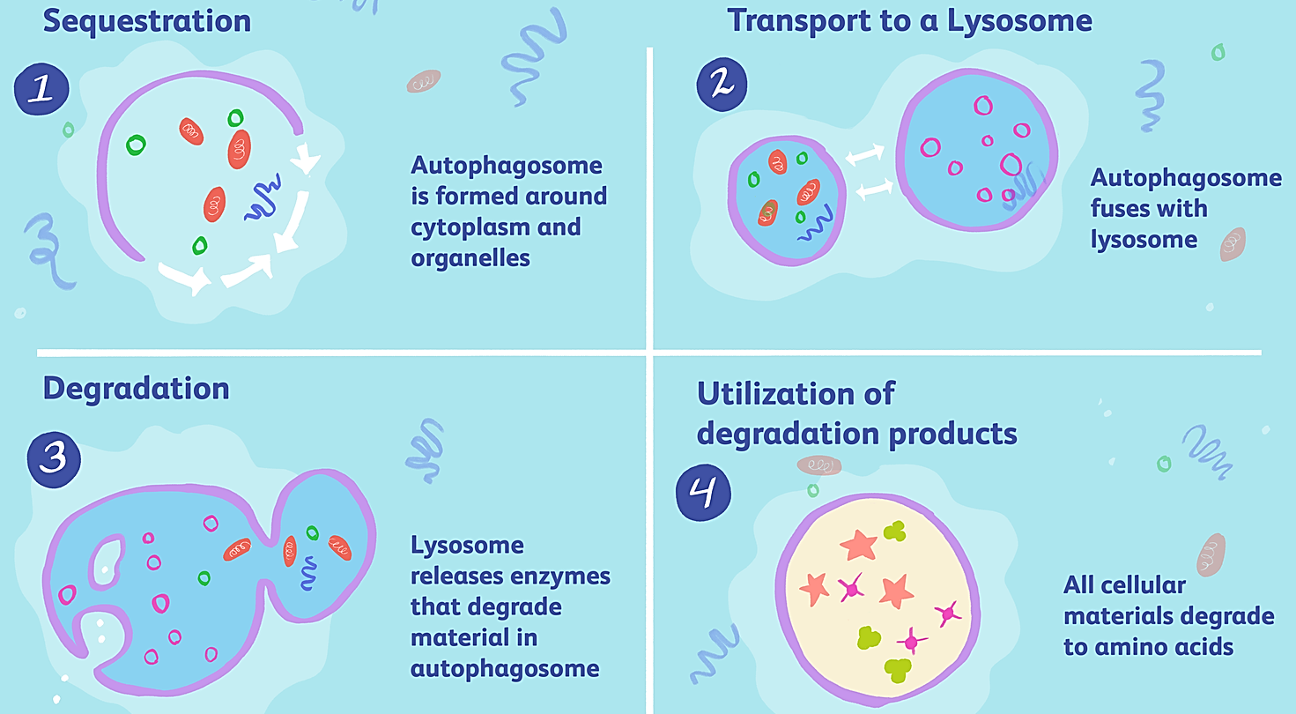
(https://www.verywellhealth.com/thmb/S14aunsdFcOKll12ooH4Zu4xofA=/1500x0/filters:no_upscale():max_bytes(150000):strip_icc()/4210008_color4-5c4e3f904cedfd0001ddb4d0.png)

The recommended `3-minute excerpt from the video, “The Inner Life of the Cell” (https://www.youtube.com/watch?v=QplXd76lAYQ&t=282s), should help students to appreciate the dynamic activity inside cells. The narration of this video is very technical. You may want to:
- listen to the narration and then turn off the sound and substitute your own, more student-friendly narration or
- have your students listen to an 11.5-minute version with easier to understand explanations, which is available at https://www.youtube.com/watch?v=dp6qRNNGPj4.
This animation is quite scientifically accurate. However, it should be noted that motor proteins actually step roughly 100 steps per second (http://book.bionumbers.org/how-fast-do-molecular-motors-move-on-cytoskeletal-filaments/).

Some important differences between plant and animal cells are shown in the figure on the top of page 5 of the Student Handout. These differences are best understood in the context of differences in how plants and animals obtain food, i.e. the organic molecules that are needed for cellular respiration and for synthesizing new molecules for growth. Obviously, plant cells need chloroplasts to photosynthesize, whereas animals eat food. (Students can learn more about the structure and function of chloroplasts in the analysis and discussion activity, “Using Models to Understand Photosynthesis” (https://serendipstudio.org/exchange/bioactivities/modelphoto).) Plants’ ability to photosynthesize means that plants do not require the mobility that many animals need to obtain food, so the rigidity of cell walls and the weight of the solution in the central vacuole are not significant disadvantages for plant cells. The turgor pressure in the central vacuole of plant cells works together with the cell wall to maintain plant structure. In contrast, animals are generally supported by a skeleton or buoyancy in water. These observations illustrate that the adaptive value of a given characteristic varies, depending on the other characteristics of an organism.

Question 12 can be used for formative assessment. I recommend that, after students develop their individual answers to question 12, each pair or small group of students should develop a consensus answer on their whiteboard. A class discussion of each group’s whiteboard will provide the opportunity to reinforce student understanding and clarify any misunderstandings.

Students can learn more about eukaryotic cells in:
– “Structure and Function of Cells, Organs and Organ Systems” (https://serendipstudio.org/exchange/bioactivities/SFCellOrgan); if you want to reinforce your students’ understanding of organelles and have them learn about the diversity of eukaryotic cells, but without discussing organs and organ systems, you can add the questions shown in Appendix 2 (pages 12-14 of these Teacher Notes) to the Student Handout.
– “Eukaryotic Cells” (https://openstax.org/books/concepts-biology/pages/3-3-eukaryotic-cells).

If you want your students to learn about a unicellular eukaryote, you can add the Challenge Question on Paramecium shown in Appendix 3.

Recommended Follow-Up Activity

Structure and Function of Cells, Organs and Organ Systems
https://serendipstudio.org/exchange/bioactivities/SFCellOrgan
In this activity, students analyze multiple examples of the relationship between structure and function in diverse human cells, in the small intestine, and in the digestive system. Students learn that cells are dynamic, with constant molecular activity. Students analyze examples that illustrate how organelles work together to accomplish cellular functions and organs and organ systems work together to accomplish functions needed by the organism. Finally, students construct and evaluate an argument to support the claim that structure is related to function in cells, organs and organ systems.

Sources for Figures in Student Handout
- Eukaryotic and prokaryotic cells – modified from https://sciencing.com/prokaryotic-vs-eukaryotic-cells-similarities-differences-13717689.html
- Relative sizes of biological objects – from https://courses.lumenlearning.com/biology1/chapter/comparing-prokaryotic-and-eukaryotic-cells/
- Animal cell (in question 10) – modified from https://s3.thingpic.com/images/ec/nwgJCGPHG9frbEHXeXy92knq.png
- Animal and plant cells – modified from Krogh, Biology – A Guide to the Natural World, 5th Edition
Appendix 1 – Possible Addition to the Student Handout Concerning Cell Size
(after question 7)

To understand why cells are so tiny, we need to think about how size affects the supply of a substance (e.g. O₂) relative to the need for the substance.
- The rate of diffusion of O₂ into a cell is proportional to the surface area of the cell.
- The rate of using O₂ is proportional to the volume of the cell.
Therefore, a cell can only survive if it has enough surface area relative to its volume.

8a. Complete this table to learn how the surface-area-to-volume ratio changes as size increases.

Hypothetical Cube-shaped Cells | Surface area (total  area of all six sides) | Volume | Surface-area-to-volume ratio
A  Length of each side = 1 µm | ______ µm² | ______ µm³ | ___ : ___
B  Length of each side = 10 µm | ______ µm² | ______ µm³ | ___ : ___

8b. In comparison to cell A, the length of each side is _____ times bigger for cell B,
the surface area is _____ times bigger for cell B, and
the volume is ______ times bigger for cell B.

9. Explain why cells are tiny. What problem would larger cells have?

Teacher Notes
As cell size increases, the surface-area-to-volume ratio decreases. Therefore, cells need to be tiny. The calculations in question 8a above are presented for a hypothetical cuboidal cell, since these calculations are relatively easy. The trends in surface-area-to-volume ratio will be similar for a spherical cell; if r is the radius of the sphere, surface area is proportional to r², volume is proportional to r³, and the surface-area-to-volume ratio is proportional to 1/r. Thus, the surface-area-to-volume ratio for either a cube or a sphere decreases as it gets larger.

Since substances like O₂ enter the cell by diffusion across the cell membrane, cell surface area limits the supply of these substances. (Some other molecules and ions are actively pumped into cells.) ("Cell Membrane Structure and Function"; https://serendipstudio.org/exchange/waldron/diffusion)

Surface area increases if the cell has thin extensions (e.g. the axons and dendrites of neurons).
This explains why diffusion across the cell membrane can supply enough O₂ for the long slender axons of the nerve cells that extend from the bottom of your spine all the way down your leg to your foot. | 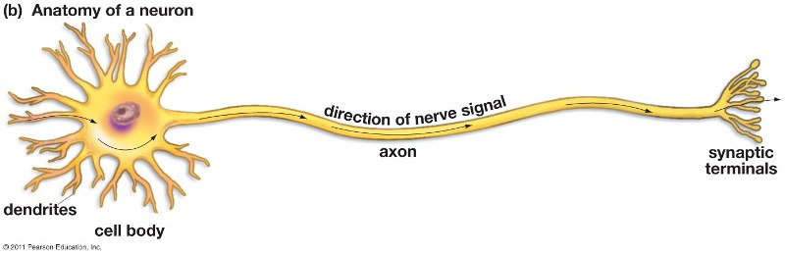  (From Krogh, Biology – A Guide to the Natural World, Fifth Edition)
Appendix 2. Possible Addition to End of Student Handout

13. If you think of a cell as a factory that makes proteins and ships them out, which parts of the cell accomplish each of the listed functions?

Factory Function | What part or parts of the cell  accomplish this function?
Management – sends out instructions
(DNA –> RNA)

Workbench – makes products (proteins)

Processing – prepares products (proteins)
to leave factory/cell

Transport – moves products (proteins)
around in factory/cell

Security Fence with Gates – controls what
comes into and leaves the factory/cell

Powerhouse – provides energy in a form
the factory/cell can use (ATP)

Cleanup crew – disposes of old and
worn out products and equipment;
prepares them for recycling

Diversity of Human Cells
Many cells in our bodies do not look like the "typical" animal cell shown on page 5. Different types of cells have different shapes and contents that match their different functions. For example, the specialized structure of sperm cells helps them to reach and fertilize eggs.

14a. Explain how the flagellum of a sperm cell contributes to sperm function. (Hint: View swimming sperm at https://sites.tufts.edu/guastolab/movies/.) | 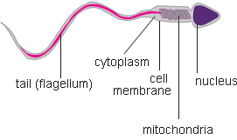

14b. Why is it an advantage for a sperm cell to have very little cytoplasm and lots of mitochondria?

The cells in your body need a constant supply of oxygen and nutrients, and they need to get rid of the carbon dioxide and other waste molecules that they produce. Your blood brings the needed inputs and takes away the cells’ waste products. Near each cell in your body is a tiny blood vessel called a capillary.
- Oxygen and nutrients diffuse from the blood in the capillary to nearby cells.
- Carbon dioxide and other waste molecules diffuse from nearby cells into the blood.

15. Explain why it is useful for the wall of a capillary to consist of a single layer of thin, flattened cells. | 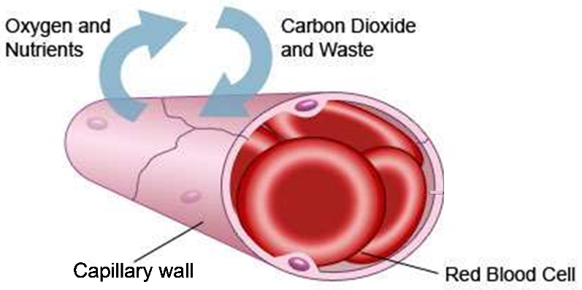

Human red blood cells are specialized to carry lots of oxygen to the body’s cells. Each red blood cell is full of hemoglobin, the protein that carries oxygen.

16a. A human red blood cell has no nucleus, ribosomes or mitochondria. Explain how this helps red blood cells to accomplish their function.

16b. Most cells are constantly replacing damaged molecules and organelles. Explain why a human red blood cell is unable to replace damaged proteins.

Phagocytes are a type of white blood cell that helps to defend the body against bacteria and viruses. Phagocytes squeeze between the cells of the capillary wall to move from the blood to an infected injury. Phagocytes capture the bacteria and viruses. Then, the chemicals and enzymes in the phagocytes’ lysosomes kill and digest the bacteria and viruses.
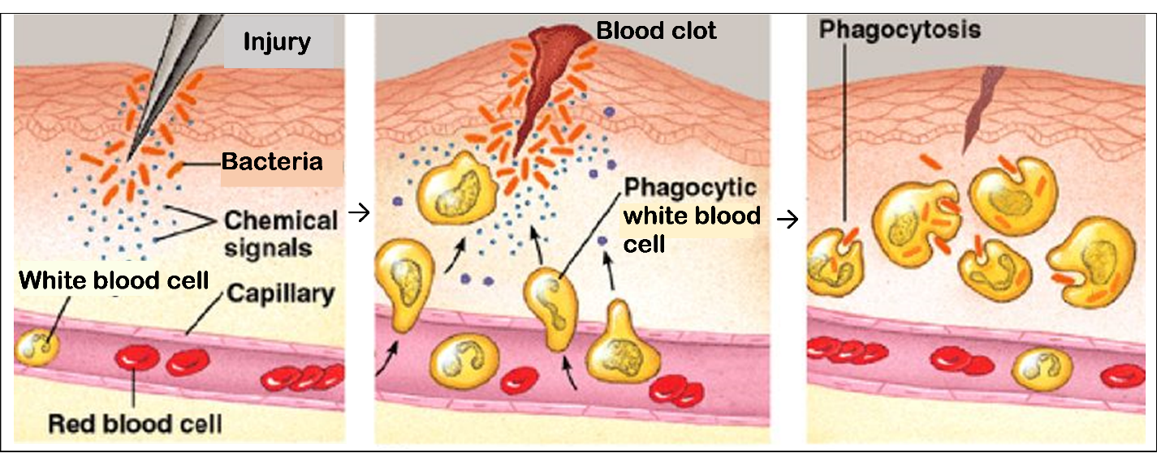

17a. Why do phagocytes need to be able to change shape in order to accomplish their function?

17b. Each phagocyte has many more lysosomes than a typical animal cell. Explain how the many lysosomes help a phagocyte accomplish its function.

18. These examples illustrate the general principle that structure is related to function. Structure includes shape, component parts, and how the parts are organized. Give examples in this table.

Cell shape is related to cell function.

Cell parts are related to cell function.

19. In a typical diagram of a cell, it looks as though nothing much is happening. In contrast, real cells are highly dynamic, with lots of activity. Briefly describe 3 examples to illustrate the kinds of activity observed in cells.

a.

b.

c.

Teacher Notes
See pages 3-6 in https://serendipstudio.org/exchange/files/StructFunctCellOrganTN.pdf.
Appendix 3. Possible Challenge Question to Add to End of Student Handout

13. A paramecium is a single cell organism. The structure of this eukaryotic cell differs from “typical” animal and plant cells. Use a reliable source such as a textbook to learn about the functions of the structures shown in this diagram. Explain how these structures support the paramecium’s activities of life (e.g., maintaining homeostasis, responding to the environment, and getting and using energy).

Teacher Notes
This question provides another example of the diversity of eukaryotic cell structure. It also challenges students to develop their skills in obtaining and evaluating information. A useful resource for students to learn about Paramecia is available at https://en.wikipedia.org/wiki/Paramecium. You may also want to recommend the first 2 minutes of Paramecium Tutorial (https://www.youtube.com/watch?v=mh7KOtQTXrw) which shows the motion of cilia, food being swept into the oral groove, and contraction of the contractile vacuoles for osmotic regulation. Seeing this video will help students understand the constant, dynamic activity in cells.

By Dr. Ingrid Waldron, Department of Biology, University of Pennsylvania, © 2024. These Teacher Notes and the Student Handout are available at https://serendipstudio.org/exchange/bioactivities/CellIntro.
Quotations are from http://www.nextgenscience.org/sites/default/files/HS%20LS%20topics%20combined%206.13.13.pdf
To draw a shape - At the top of the page, find and click Shape. - Choose the shape you want to use. - Click and drag on the canvas to draw your shape. To insert text - At the top of the page, click Insert. - To place text inside a box or confined area, click Text Box and drag it to where you want it. - Type your text. - You can select, resize and format the word art or text box, or apply styles like bold or italics to the text. When you are done, click Save and Close.
In contrast, billions of years ago cells arose by evolution from aggregates of molecules.
Recent research has shown that many prokaryotic cells have more internal structure than was previously believed. Various prokaryotes have internal membranes, including one group of bacteria that has a membrane that surrounds their DNA (https://journals.plos.org/plosone/article?id=10.1371/journal.pone.0091344). You may want to reinforce student understanding of the differences between prokaryotic and eukaryotic cells by showing the 2.5-minute video, “Learn About the Similarities and Differences Between Eukaryotic and Prokaryotic Cells” (to find the video, scroll down at https://www.britannica.com/science/cell-biology/images-videos ). This video uses a definition of organelles that excludes ribosomes, which is different from the definition in this activity.
In prokaryotic cells, in addition to the circular chromosome, there are often small circles of DNA called plasmids, which can be exchanged between prokaryotic cells, even of different species. In eukaryotic cells, in addition to the DNA in the nucleus, there is DNA in the mitochondria and, for plant cells, also in the chloroplasts. This is one reason why most biologists believe that eukaryotic cells evolved, in part, by endosymbiosis (a prokaryotic cell taking up permanent residence within another cell).
If you want to reinforce the relative sizes of molecules and cells, you can use the Card Sort Activity, From Coffee to Carbon, available at https://teach.genetics.utah.edu/content/cells/files/Coffee-to-Carbon.pdf. This activity has students sort cards (each with a molecule, organelle or cell) according to size. To use this card sort activity to reinforce student understanding of the relationship between molecules and cells, I recommend that you begin by having your students sort the cards into four categories: molecules, organelles, cells, and other. After you have discussed this initial card sort, then have your students organize the cards from smallest to largest. (Depending on your students, you may want to omit some cards such as adenine and baker's yeast.) This card sort would complement the recommended animation (https://learn.genetics.utah.edu/content/cells/scale/). The orders of magnitude differences in size can be used to help students realize that eukaryotic cells are made up of many many organelles and each organelle is made up of many many molecules.
Some scientists argue that bacteria and archaea are so different that we should stop using the term prokaryotes. These scientists fear that the use of the term “prokaryotes” could be interpreted to mean that bacteria and archaea are more closely related evolutionarily than archaea and eukaryotes. Contrary to this interpretation, contemporary molecular research indicates that archaea and eukaryotes are more closely related evolutionarily, and some archaea may even have been the evolutionary ancestors of eukaryotes (https://www.frontiersin.org/articles/10.3389/fmicb.2018.01896/full#:~:text=A%20Briefly%20Argued%20Case%20That%20Asgard%20Archaea%20Are%20Part%20of%20the%20Eukaryote%20Tree,-Gregory%20P.&text=The%20recent%20discovery%20of%20the,origin%20of%20the%20eukaryote%20cell). In this activity, I have taken the point of view that the term “prokaryotes” is a convenient shorthand for cells which do not have a true nucleus and is suitable for use in this introductory activity.
The nucleus, ribosomes, rough endoplasmic reticulum, and Golgi apparatus also cooperate to synthesize proteins that will be embedded in membranes.
The sphere in the middle of the nucleus in the figure that compares animal and plant cells is the nucleolus, where ribosomes are produced.
On the top of page 5 of the Student Handout, I have followed the common convention that photosynthesis produces glucose. Actually, photosynthesis produces three-carbon molecules which can be used to make glucose or fructose, which in turn can be combined to make sucrose, the disaccharide that is transported in plants.
For this purpose, you will want one whiteboard per student group in your largest class. For information about how to make inexpensive whiteboards and use them in your teaching, see "The $2 interactive whiteboard" and "Resources for whiteboarding" in https://fnoschese.wordpress.com/2010/08/06/the-2-interactive-whiteboard/. To obtain whiteboards, you can go to Home Depot or Lowe's and ask them to cut a 8' x 4' whiteboard (e.g. EUCATILE Hardboard Thrifty White Tile Board) into six pieces with the dimension 32" x 24". They should have a power saw rig that allows their employees to cut the pieces very easily. They should not charge to cut them and the product cost is reasonable. Some important tips for using whiteboards: – Coat the white boards with Endust (or similar product) before using. Every once in a while, wipe them clean and reapply Endust. – Black markers are easiest to erase. To prevent stains, erase right away, especially red or green markers. Do not use markers that are old or almost empty, since the ink from these is more difficult to erase. Recommended brands are Expo markers and Pilot BeGreen markers. To clean up stains you can use Windex or Expo Whiteboard Cleaner. – Teacher and/or students can take a picture of the information on the board if they want to save it.
The figure in the question is modified from https://www.pngitem.com/pimgs/m/374-3745167_nutrition-in-paramecium-diagram-hd-png-download.png.

